# Algol – an Eclipsing Binary Star System

Jeremy Maniago, Professor James Hedberg

PHYS 454 – Introduction to Astrophysics

## Abstract

Binary stars are systems are a type of multiple star system consisting of two stars. Their orbits and even their properties are influenced by their companion stars. It is modeled as a simple two-body problem. Binaries are categorized based on how they are primarily detected. This project will focus on a famous eclipsing binary named Algol, in which was studied due to its variable brightness (eclipsing binaries are variable stars). Use of orbital parameters will aid in visualizing the orbit of the Algol binary system in 3D, and projections of this plot based on our line of sight from the Earth will be utilized to infer how the light curve of the system will behave. Future work on mass transfer and simulated light curve data is conceptualized.

## Introduction

The universe, although vast, is populated with stars. It would not be a surprise if up to 85% of stars are part of a multiple star system, like a binary star system [2]. Binary Stars are celestial systems consisting of two stars. Their orbits are influenced by each other and are often modelled as a two-body problem – a problem with analytical solutions, although solved more efficiently through numeral solutions. Binary stars can also be categorized as a Variable Star, depending on the detection method of the Binary Star system. The following sections will go over the motivation in researching and observing binary star systems as well as different types of binary stars.

## Motivation

Why are binary stars important? Binaries have aided astronomers in determining different properties of stars, including the masses, radii, temperatures, age, etc. Additionally, they are “extremely useful as distance indicators, allowing astronomers to measure the distance to the clusters and galaxies where they are found. Historically the study of binaries and variables has changed our understanding of the scale of the Universe” [3]. Unique binary stars also help with studying the stellar evolution of stars and, if the stars are close enough in the binary system, mass transfer between them.

## Types of Binary Star Systems

1. Visual Binaries – These binaries are the easiest to spot, as each star in the system can be “individually resolved” [4], meaning that there is a clear distinction between one star and its companion. The orbital plane is at an angle such that the orbit of each star can be easily mapped out.
2. Spectroscopic Binaries – Binaries that are too distant to be visual and are detected by using the change in the stars’ spectral lines due to Doppler shift. Red or blue shifts will indicate whether the star in the system is approaching or moving away from us.
3. Eclipsing Binaries – Characterized by a dimming of total luminosity of the system. This is due to the orbital plane of the system being parallel or near parallel to our line of sight. The eclipsing, or the occasional dimming in luminosity, is usually periodic and thus the period of a star’s orbit and radius can be determined.

It is also noteworthy to mention that Binaries appear in multiple categories. Most binaries that have star data and orbital parameters usually use methods of spectroscopic and eclipsing binaries to obtain various characteristics of the individual stars of the system.

## The “Demon Star”

Algol, also known as the “Demon Star”, is a triple star system located in the constellation of Perseus. Although there *are* three stars, the orbit of the third is relatively far compared to the pair that interact with each other. Algol coined the title “Demon Star” because of its variability in brightness.

The eclipsing binary system consists of a larger but less massive star (Beta Persei Aa2) orbiting a slightly smaller but larger mass star (Beta Persei Aa1). The orbit is circular, as the eccentricity is given as 0. The apparent magnitude of Aa1 and Aa2 is -0.07 and 2.9, respectively. This means that the orbiting star, Aa2, is less luminous than Aa1. Aa1 has a mass of 3.17 M­ʘ (Solar Mass) and a radius of 2.73 Rʘ (Solar Radius) while Aa2 has a mass of 0.70 M­ʘ and a radius of 3.48 Rʘ. Since Aa2 is orbiting Aa1 and the orbit is circular, the center of the orbit is about Aa1. **Table 1** shows various orbital elements of the orbit of Beta Persei Aa2.

|  |  |
| --- | --- |
| β Per Aa2 Orbital Elements | |
| Period [days] | 2.867 |
| Semi-major axis [arcsec] | 0.00215 |
| Eccentricity | 0 |
| Inclination [deg] | 98.70 |
| Longitude of the node [deg] | 43.43 |

*Table 1: Orbital Elements of Aa2 about Aa1.*

## Setup and Analysis Tools

The math and plotting are done in Python. Google Collab was an initial workspace used but ultimately python scripts were created in a local Visual Studio (VS) code workspace. Packages such as NumPy are used for math, arrays, matrices, etc. The matplotlib library was used for plotting and animations. The PIL image library is a prospective library to be utilized for further image processing.

## Analysis

Due to the nature of Aa2’s orbit, the only parameter needed to plot a circle is the semi-major axis. Given in arcseconds, and the fact that the Algol system is approximately 28 parsecs from the Earth, the semi-major axis of the orbit is found to be 0.062 AU, which is less than a tenth of the distance between the Earth and our Sun. **Figure 1** shows the orbit of Aa2 about Aa1, along with the relative sizes (and approximate colors based on temperatures) of each star.

Figure : Orbit (blue) of Aa2 (orange) about Aa2 (blue-white)

This plot was also rotated given the inclination and longitude of the node of the orbit. These angles are the Euler angles of the orbit and led to the creation of a rotation matrix, which was then applied onto the previous circular orbit (which was only on the x-y plane). Now, we can orient the plot so that the z direction is parallel to our line of sight. The x and y positions of the orbit and each star can be projected from the 3D plot onto the 2D x-y plane, as shown in **Figure 2**.

In fact, this is an approximate perspective of how telescope views this system, as shown in **Figure 3**.

Figure : Projected view of Algol System onto x-y plane.

Figure : Interferometer image of Algol System [5]

Re-introduce light curves. Show the four phases of the eclipsing binary (full, primary, secondary).

Describe predicted light curve and compare it to real light curve data.

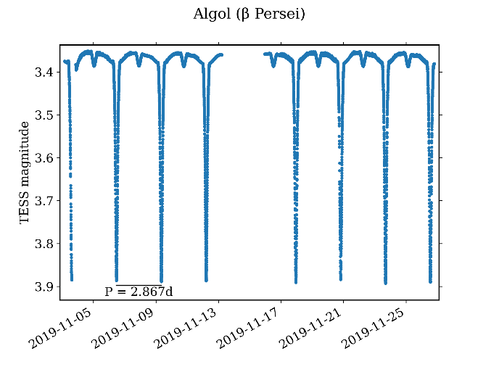

## Discussion

Recall Algol paradox. Describe solution being mass transfer.

Lessons learned, in terms of project timeline, tools, coding, etc.

Possible future work and general feelings about project in terms of open ended-ness and topic itself.

## References

1. [Spring 2024 PHYS454 CCNY (cuny.edu)](https://hedberg.ccnysites.cuny.edu/PHYS454/)
2. [Introduction to Binary Stars (csiro.au)](https://www.atnf.csiro.au/outreach/education/senior/astrophysics/binary_intro.html)
3. [Binary and Variable Stars (csiro.au)](https://www.atnf.csiro.au/outreach/education/senior/astrophysics/binary_variabletop.html)
4. [Types of Binary Stars (csiro.au)](https://www.atnf.csiro.au/outreach/education/senior/astrophysics/binary_types.html)
5. <https://en.wikipedia.org/wiki/Algol>
6. [Two-Body Numerical Solution in an Inertial Frame — Orbital Mechanics & Astrodynamics (orbital-mechanics.space)](https://orbital-mechanics.space/the-n-body-problem/two-body-inertial-numerical-solution.html)